**Pogglewash Unreal Animation Document**

Frankie Camarillo – Team Lavendeer

Overview

The player animation and Pogglewonk animation blueprints control which animations will play depending on variables communicating via their respective blueprints.

Core functions

* Blendspaces for walking
* A state machine
* Sockets to visually help with mechanics
* Audio Implementation

The State Machine (Player)

Figure The player animation blueprint's state machine

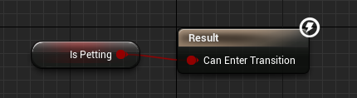The state machine in the animation blueprint allows a skeletal model to play animations created by the user. It is implemented for the player by checking variables set in the player character blueprint and mimicking those variables in the animation blueprint.

A transition between states occurs when a Boolean is true. This is the case for most of the animations in the game unless it needs to play a sequence of animations.

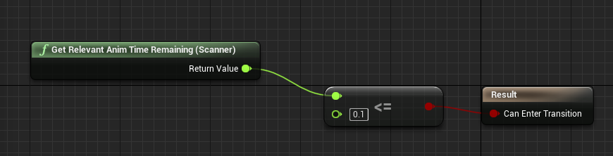In some cases, what needed to be done is to check the time remaining in an animation to exit said animation.

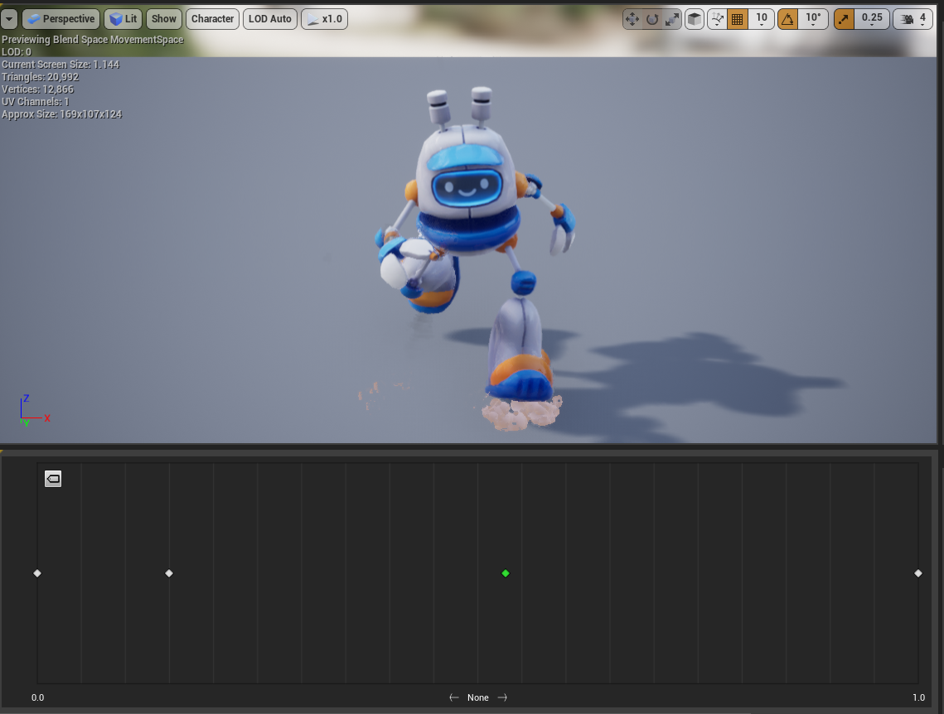Animation Blendspaces

Figure A preview of a blend space blueprint in unreal

When we were adding controller support to our game we introduced walking around as a different type of movement based on how the joysticks were used. Because we had a variable speed at which the player could run, we needed a way to blend those animations together. A solution was the animation blend spaces provided by unreal.

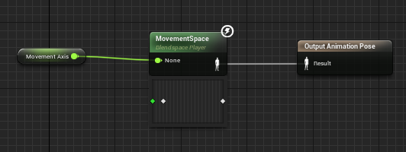

I created a blend space that used the idle, walk, and run animations and based on the input axis from the controller, we used it to determine what animation should play. This also allowed us to blend the animations together to create a movement for any speed between the walk and run. It also had the nice side effect of creating a short transition to the run due to the analog input of the joystick.

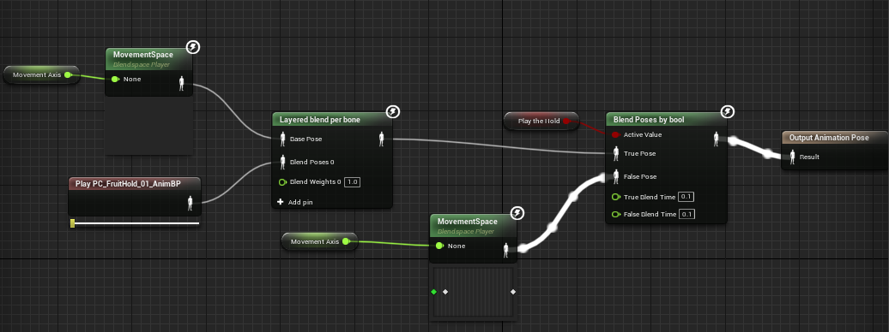The Fruit Mechanic

When we created the fruit-holding mechanic, we needed to figure out a way to show the player holding the fruit. Instead of creating separate animations for carrying the fruit when walking, I created a simple system that blends specific parts of the skeleton. In the screenshot above you can see the function called layered blend by bone, this is a blend function that only blends parts of the skeleton given a bone. All that was needed was an animation in which the player was holding the fruit, then we just had to blend the two animations. What we got was us reusing the same animations as before, but we now have the player holding a fruit.

Figure Animation preview of the player holding a fruit and running

The Pogglewonk Animation Blueprint

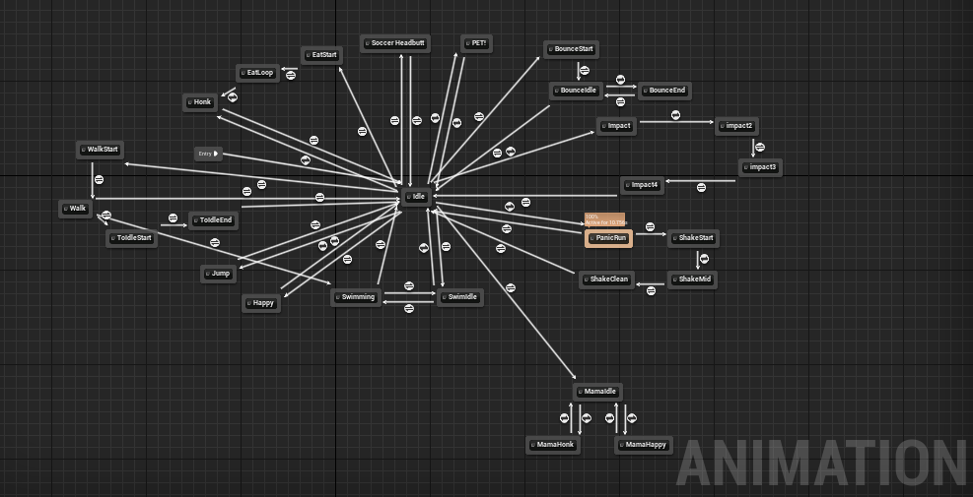

Figure The Pogglewonk state machine in its animation blueprint

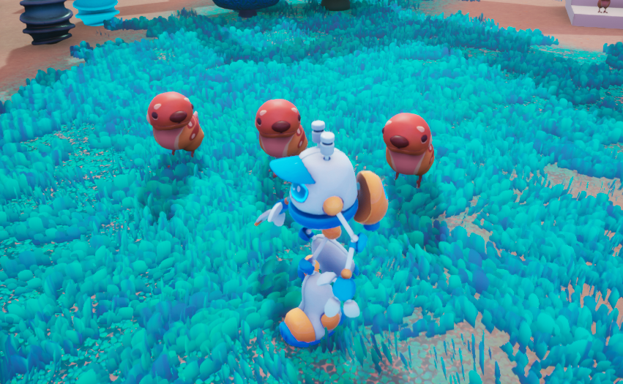Implementing the Pogglewonks was fairly straightforward, which left room for me to experiment on their animations. One of my favorite features I implemented was having the Pogglewonk stare at the player if they were in the field of view of said Pogglewonk.

Unreal allows the developer to modify specific bones of a skeletal mesh in the animation blueprints, thanks to this it allowed me to rotate the heads of the Pogglewonks. In the screenshot above I showcase how it works in the actual animation using a variable called head rotation.

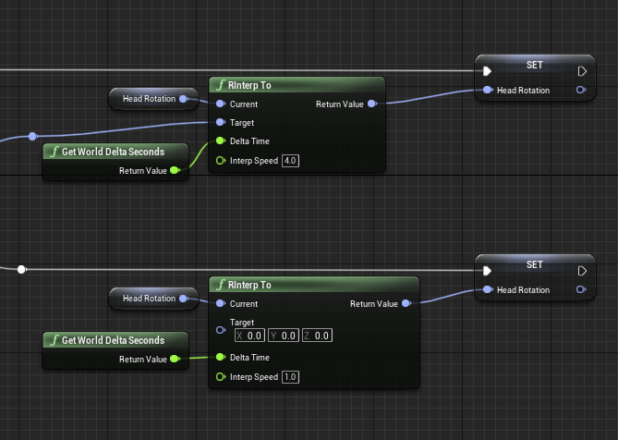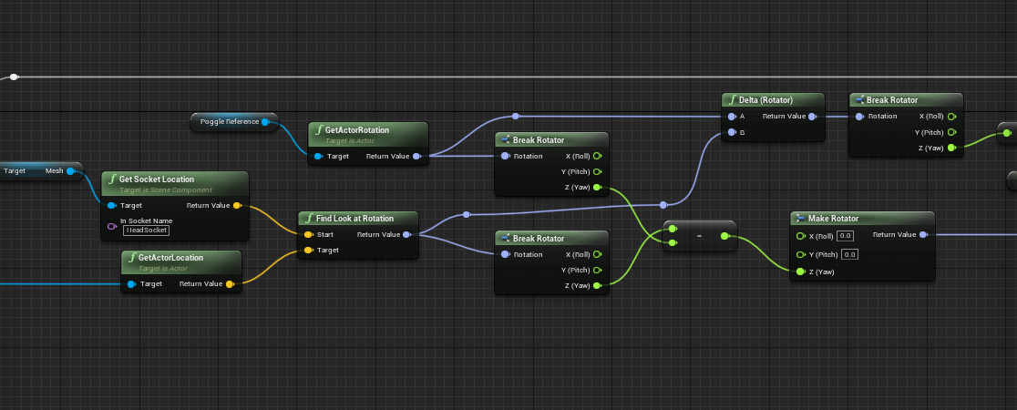

Figure "RInterp To" is used to smoothly turn the head. Otherwise the Pogglewonk would harshly turn its head.

Here is how I calculated said head rotation. Inside the neck of the Pogglewonk was a socket that was used to determine the angle from the Pogglewonk to the player. Once this angle was determined, we only used the z-axis (yaw) to add to the head rotation. I could have also made the Pogglewonks state upwards at the player, however, there were problems with the rig that caused too much vertical head movement to look unpleasant.